**Folder Change Trigger**

This document shows how to use **Folder Change Trigger**.

**Step 1:** Right click on Zap icon and select **Task Editor** or double click on **Zap** icon.

**Step 2:** Drag and Drop **Folder Change Trigger** and set the properties.

* **FolderPath –** Enter the Folder Path where user have to set trigger.
* **NotificationDelay –** Set time in milliseconds.
* **NotifyFilters –** Select the option from drop down menu. Trigger will when fire the Directory Name, File Name, Attributes are changed.
* **WatcherChangeType:** Select the watcher Type means trigger will also fire when the folder is deleted or moved.

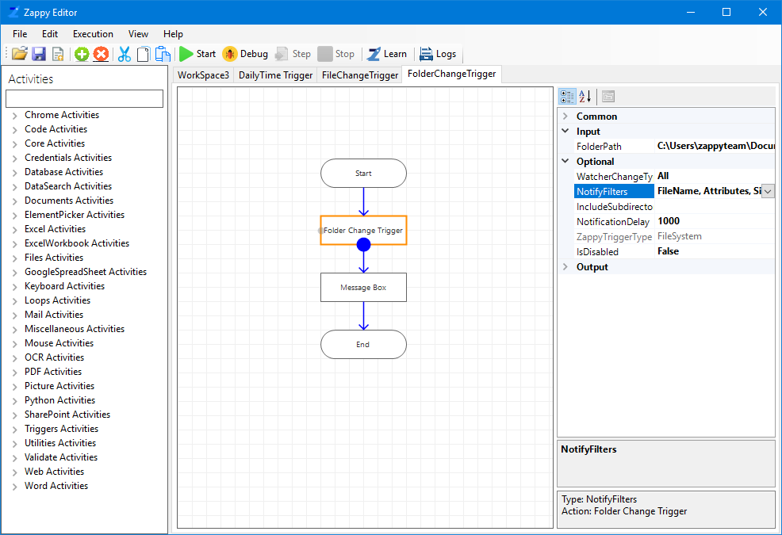

Set folder path

In this example we have only shown the message box will display when any changes made in the selected folder. We can also add another action / automation flow according to our requirement.

**Step 3:** Click on Start.

You will see message for trigger

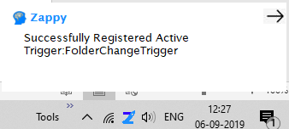

**Step 4:** Whenever we make any changes in that folder, then Folder Change trigger will fire.

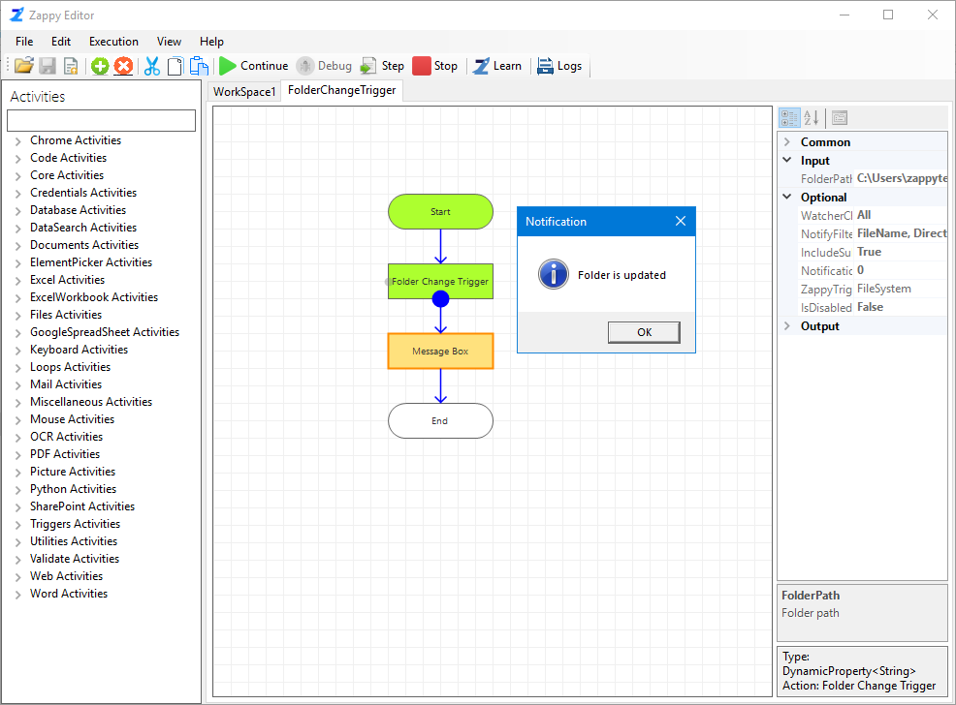

**Likewise, we can use this trigger for Important Folders.**